In this scenario we are going to insert the employee’s data into the database dynamically using the Database Activities by Retrieving the data from the FTP location.

In order use the **Database Activities** we need to install the Database Activities pack from the **Manage Packages** tab. Select the **Manage packages** in the **Design** tab and in the Manage Packages window click on **Official** and in the search bar search for database then we can see the **Database package** now click on **Install** and finally click on Save.

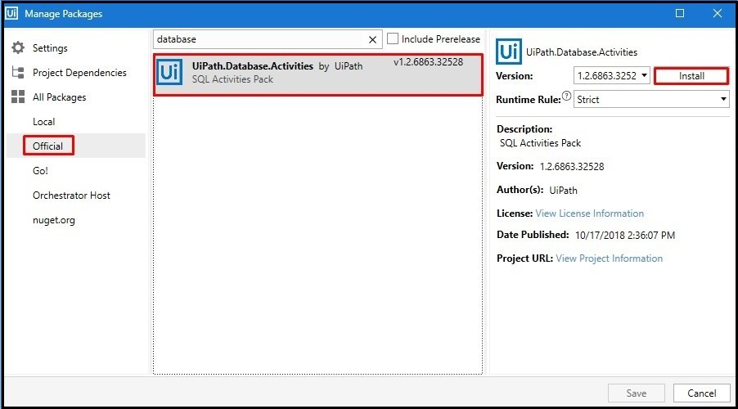

To use the **FTP** activities, we need to follow the above same steps and download the activities from the **Manage Package**.

To create a new Sequence, navigate to **Design** tab and in the **New** tab select Sequence, then enter the sequence name as requiredthen click on create and the sequence is created.

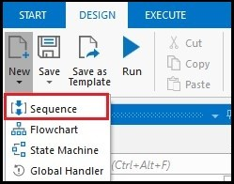

Drag and drop the FTP**Download**activity and click on the Configure Connection filed and provide the details to connect with the FTP server. After providing all the details like Host, Port, Username and Password click on Test Connection, if the connection is successful then click on OK.

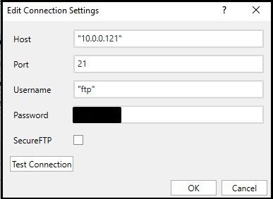

Then In the first text box filed of the FTP **Download**activity provide the local disk path where the extracted file will be downloaded this filed support only strings

In the Second text box field provide the FTP directory path from where the file should be extracted. This field supports string only.

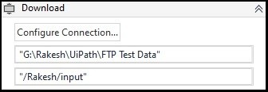

Now drag and drop the **Read Range** activity and select the excel file which we will be downloading from the FTP location in to our Local Disk and in the **Range** Tab leave it empty or simply put two double quote such that whole excel file will be read. Then create an output Datatable variable in order to store the data read by the **Read Range** activity.

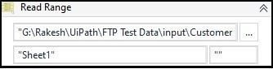

Then drag and drop the **Connect** database activity, which is used to connect to the database which we want to connect. Then click on configure connection.

No alt text provided for this image

After clicking on the Configure connection we will get an **Edit Connection Settings** pop up window.

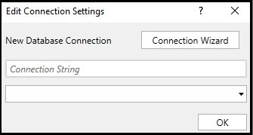

Now click on the **Connection Wizard** button and In the Choose Data Source window select Microsoft ODBC Data Source and click on Okay.

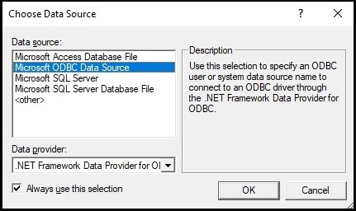

Then in the connection properties select the system source name in **Use user or system data source name**field and in the Login Information give the database **UserName** and **Password** and click on **Test Connection** an if the test connection is successful click on **OK**.

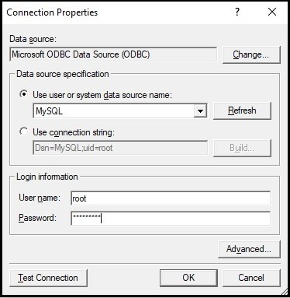

Then in properties tab **DatabaseConenction** field create a DatabaseConnection variable with required name which can be used in further database activities.

Now drag and drop the For Each Row activity and in the input DataTable variable filed assign the previously created DataTable variable in the Read Range activity.

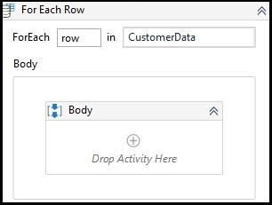

In the body of the For Each Row drag and drop the Execute Query activity and click on the Configure Connection and in the Edit Connection Setting provide the previously created **Existing Database Connection** variable in the Existing Database Connection filed and click on OK.

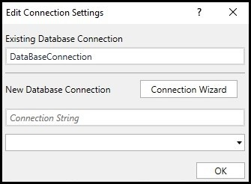

Then in the Sql Query text field provide the Sql Query to send the data to the database dynamically from the excel file.

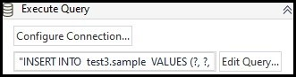

The Sql query used in this scenario is:

**"INSERT INTO test3.sample VALUES (?, ?, ?, ?);"**

As we are sending the values dynamically in to the database we use ‘?’ instead of the values.

Finally save the process and click on the Start button and the process starts executing, first the bot downloads the file from the Ftp server to the local path and then it reads the data from the file and populate the same in to the Database.

Below screenshot displays the employee’s data that has been populated to the Database.

